**Task**: Create a web-based application for Library Management System  
  
**Problem Statement**:  
  
Build a simple library management page where  
  
● Users should be able to see the list of books  
                     ○ Instead of loading all the results on the page, perform paging on the list of books – either implement 10 results per page or load on scroll will be a bonus  
  
● Users should be able to filter the list of books based on Title, Author, Subject and Publish - date  
                     ○ User should be able to see the count of books in based on each criteria [ Title, Author, Subject and publish-date ]

**Github Repo Link:**

https://github.com/saipavan044/Library-Management

**Code:**

Library Management.html

<!DOCTYPE html>

<html>

<title>Library Management</title>

<style>

*{

box-sizing: border-box;

}

body {

background-color: #f1f1f1;

padding: 20px;

font-family: Roboto Slab;

font-size: 20px;

color: #f1f1f1;

}

#page11{ display: block ; } #page12{ display: block ; } #page13{ display: block ; }

#page14{ display: block ; } #page15{ display: block ; } #page16{ display: block ; }

#page17{ display: block ; } #page18{ display: block ; } #page19{ display: block ; }

#page21{ display: none ; } #page22{ display: none ; } #page23{ display: none ; }

#page24{ display: none ; } #page25{ display: none ; } #page26{ display: none ; }

#page27{ display: none ; } #page28{ display: none ; } #page29{ display: none ; }

#page31{ display: none ; } #page32{ display: none ; } #page33{ display: none ; }

.main {

max-width: 1000px;

margin: auto;

}

h1 {

font-size: 50px;

word-break: break-all;

}

.row {

margin: 10px -16px;

}

.row,

.row > .column {

padding: 8px;

}

.column {

float: left;

width: 33.33%;

}

.row:after {

content: "";

display: table;

clear: both;

}

.content {

padding: 10px;

}

.show {

display: block;

}

.center {

text-align: center;

}

.pagination a{

color: black;

padding: 10px 15px;

text-decoration: none;

}

.pagination a.active{

background-color: rgb(195, 195, 195);

color: white;

}

.pagination a:hover:not(.active) {

background-color: lightgray;

}

h1{

font-family: "Optima";

}

body {

background: linear-gradient(-45deg, #ee7752, #e73c7e, #23a6d5, #23d5ab);

background-size: 400% 400%;

animation: gradient 15s ease infinite;

height: 100vh;

}

@keyframes gradient {

0% {

background-position: 0% 50%;

}

50% {

background-position: 100% 50%;

}

100% {

background-position: 0% 50%;

}

}

</style>

<head>

<script src="https://ajax.googleapis.com/ajax/libs/jquery/2.1.1/jquery.min.js"></script>

</head>

<body>

<h1>Library Management</h1>

<hr>

<div class="filter">

<h4>Filtering Options</h4>

<div class="Title">

<label><b>Title</b></label> &nbsp;

<input id="filter" type="text" size="50" placeholder="Enter Text..">

</div>

</div>

<h4>Author</h4>

<div class="Author">

<label><input type="checkbox" rel="Rajaraman" onchange="change();"/> Rajaraman</label>

<label><input type="checkbox" rel="Ghosh" onchange="change();"/> Ghosh</label>

<label><input type="checkbox" rel="Yegnanarayana" onchange="change();"/> Yegnanarayana</label>

<label><input type="checkbox" rel="Krishnamurthy" onchange="change();"/> Krishnamurthy</label>

<label><input type="checkbox" rel="Gupta" onchange="change();"/> Gupta</label>

<label><input type="checkbox" rel="Robert" onchange="change();"/> Robert</label>

<label><input type="checkbox" rel="Ashok" onchange="change();"/> Ashok</label>

<label><input type="checkbox" rel="Duggal" onchange="change();"/> Duggal</label>

<label><input type="checkbox" rel="Michael" onchange="change();"/> Michael</label>

</div>

<div class="column">

<h4>Subject</h4>

<div class="Subject">

<label><input type="checkbox" rel="CSE" onchange="change();"/> CSE</label>

<label><input type="checkbox" rel="MECH" onchange="change();"/> MECH</label>

<label><input type="checkbox" rel="CIVIL" onchange="change();"/> CIVIL</label>

</div>

</div>

<h4>Publish Year</h4>

<div class="PublishYear">

<label><input type="checkbox" rel="1990" onchange="change();"/> 1990</label>

<label><input type="checkbox" rel="2000" onchange="change();"/> 2000</label>

<label><input type="checkbox" rel="2010" onchange="change();"/> 2010</label>

<label><input type="checkbox" rel="2020" onchange="change();"/> 2020</label>

</div>

<h4>Sorted Books Count </h4>

<label id="result1"></label>

<div id="res">

<div class="row">

<div class="result">

<hr>

<div id="page11" class="content column CSE Rajaraman 1990">

<h4>Analog computation and simulation</h4>

<p>Author: Rajaraman</p>

<p>Subject: CSE</p>

<p>Publish Year: 1990 </p>

</div>

<div id="page12" class="content column CSE Rajaraman 2000">

<h4>Computer programming in COBOL</h4>

<p>Author: Rajaraman </p>

<p>Subject: CSE</p>

<p>Publish Year: 2000</p>

</div>

<div id="page13" class="content column CSE Ghosh 2010">

<h4>Foundations of parallel processing</h4>

<p>Author: Ghosh</p>

<p>Subject: CSE</p>

<p>Publish Year: 2010</p>

</div>

<div id="page14" class="content column CSE Rajaraman 2000">

<h4>Information Systems</h4>

<p>Author: Rajaraman</p>

<p>Subject: CSE</p>

<p>Publish Year: 2000</p>

</div>

<div id="page15" class="content column CSE Ghosh 1990">

<h4>Natural language processing</h4>

<p>Author: Ghosh</p>

<p>Subject: CSE</p>

<p>Publish Year: 1990</p>

</div>

<div id="page16" class="content column CSE Rajaraman 2020">

<h4>Information Systems</h4>

<p>Author: Rajaraman</p>

<p>Subject: CSE</p>

<p>Publish Year: 2020</p>

</div>

<div id="page17" class="content column CSE Yegnanarayana 2020">

<h4>Artificial neural networks</h4>

<p>Author: Yegnanarayana</p>

<p>Subject: CSE</p>

<p>Publish Year: 2020</p>

</div>

<div id="page18" class="content column CSE Krishnamurthy 2010">

<h4>Programming in MATLAB</h4>

<p>Author: Krishnamurthy</p>

<p>Subject: CSE</p>

<p>Publish Year: 2010</p>

</div>

<div id="page19" class="content column CSE Krishnamurthy 1990">

<h4>Theory of computer science</h4>

<p>Author: Krishnamurthy</p>

<p>Subject: CSE</p>

<p>Publish Year: 1990</p>

</div>

<div id="page21" class="content column MECH Gupta 2010">

<h4>A Textbook of Machine Design</h4>

<p>Author: Gupta</p>

<p>Subject: MECH </p>

<p>Publish Year: 2010 </p>

</div>

<div id="page22" class="content column MECH Robert 2000">

<h4>An Introduction to MechanicsL</h4>

<p>Author: Robert </p>

<p>Subject: MECH</p>

<p>Publish Year: 2000</p>

</div></tr>

<div id="page23" class="content column MECH Gupta 2010">

<h4>Design of Machine Elements</h4>

<p>Author: Gupta</p>

<p>Subject: MECH</p>

<p>Publish Year: 2010</p>

</div>

<div id="page24" class="content column MECH Rajaraman 2000">

<h4>A Textbook of MATLAB Design</h4>

<p>Author: Rajaraman</p>

<p>Subject:MECH</p>

<p>Publish Year: 2000</p>

</div>

<div id="page25" class="content column MECH Robert 1990">

<h4>Basic & Applied Thermodynamics</h4>

<p>Author: Robert</p>

<p>Subject: MECH</p>

<p>Publish Year: 1990</p>

</div>

<div id="page26" class="content column MECH Gupta 2020">

<h4>Engineering Mechanics</h4>

<p>Author: Gupta</p>

<p>Subject: MECH</p>

<p>Publish Year: 2020</p>

</div>

<div id="page27" class="content column CIVIL Ashok 1990">

<h4>Surveying</h4>

<p>Author: Ashok</p>

<p>Subject: CIVIL</p>

<p>Publish Year: 1990 </p>

</div>

<div id="page28" class="content column CIVIL Duggal 2000">

<h4>Design of Steel Structures</h4>

<p>Author: Duggal </p>

<p>Subject: CIVIL</p>

<p>Publish Year: 2000</p>

</div></tr>

<div id="page29" class="content column CIVIL Ashok 2010">

<h4>Structural Dynamics</h4>

<p>Author: Ashok</p>

<p>Subject: CIVIL</p>

<p>Publish Year: 2010</p>

</div>

<div id="page31" class="content column CIVIL Duggal 2000">

<h4>Reinforced Concrete Design</h4>

<p>Author: Duggal</p>

<p>Subject: CIVIL</p>

<p>Publish Year: 2000</p>

</div>

<div id="page32" class="content column CIVIL Michael 1990">

<h4>Civil Engineering Materials</h4>

<p>Author: Michael</p>

<p>Subject: CIVIL</p>

<p>Publish Year: 1990</p>

</div>

<div id="page33" class="content column CIVIL Michael 2020">

<h4>Civil Engineering: Conventional</h4>

<p>Author: Michael</p>

<p>Subject: CIVIL</p>

<p>Publish Year: 2020</p>

</div>

<div class="center">

<hr><br>

<div class="pagination" >

<a href="#">«</a>

<a href="#" onclick='showPages("1")'>1</a>

<a href="#" onclick='showPages("2")'>2</a>

<a href="#" onclick='showPages("3")'>3</a>

<a href="#">»</a>

</div>

</div>

</div>

</div>

</div>

<script>

$("#filter").keyup(function() {

var filter = $(this).val(),

count = 0;

$('#res div').each(function() {

if ($(this).text().search(new RegExp(filter, "i")) < 0) {

$(this).hide();

}

else {

$(this).show();

count++;

}

});

});

function showPages(id){

var totalNumberOfPages = 3;

var n=0;

for(var i=1; i<=totalNumberOfPages; i++){

if (document.getElementById('page'+i)) {

document.getElementById('page'+i).style.display='none';

}

}

if (id==1||id==2){

n=9;

}

else{

n=3;

}

for(var j=1; j<=totalNumberOfPages; j++){

for(var i=1; i<=9; i++){

if(j==3){

if(i==4){

break;

}

}

if (document.getElementById('page'+j+i)) {

document.getElementById('page'+j+i).style.display='none';

}}

}

for(var i=1; i<=n; i++){

if (document.getElementById('page'+id+i)) {

document.getElementById('page'+id+i).style.display='block';

}}

}

function change() {

var AuthorCbs = document.querySelectorAll(".Author input[type='checkbox']");

var PublishYearCbs = document.querySelectorAll(".PublishYear input[type='checkbox']");

var SubjectCbs = document.querySelectorAll(".Subject input[type='checkbox']");

var filters = {

authors: getClassOfCheckedCheckboxes(AuthorCbs),

publishyears: getClassOfCheckedCheckboxes(PublishYearCbs),

subjects: getClassOfCheckedCheckboxes(SubjectCbs)

};

filterResults(filters);

}

function getClassOfCheckedCheckboxes(checkboxes) {

var classes = [];

if (checkboxes && checkboxes.length > 0) {

for (var i = 0; i < checkboxes.length; i++) {

var cb = checkboxes[i];

if (cb.checked) {

classes.push(cb.getAttribute("rel"));

}

}

}

return classes;

}

function filterResults(filters) {

var rElems = document.querySelectorAll(".result div");

var hiddenElems = [];

var count1=0,f1=0;

var count2=0,f2=0;

var count3=0,f3=0;

if (!rElems || rElems.length <= 0) {

return;

}

for (var i = 0; i < rElems.length; i++) {

var el = rElems[i];

if (filters.authors.length > 0) {

var isHidden = true;

f1=1;

for (var j = 0; j < filters.authors.length; j++) {

var filter = filters.authors[j];

if (el.classList.contains(filter)) {

isHidden = false;

count1+=1;

break;

}

}

if (isHidden) {

hiddenElems.push(el);

}

}

if (filters.publishyears.length > 0) {

var isHidden = true;

f2=1;

for (var j = 0; j < filters.publishyears.length; j++) {

var filter = filters.publishyears[j];

if (el.classList.contains(filter)) {

isHidden = false;

count2+=1;

break;

}

}

if (isHidden) {

hiddenElems.push(el);

}

}

if (filters.subjects.length > 0) {

var isHidden = true;

f3=1;

for (var j = 0; j < filters.subjects.length; j++) {

var filter = filters.subjects[j];

if (el.classList.contains(filter)) {

isHidden = false;

count3+=1;

break;

}

}

if (isHidden) {

hiddenElems.push(el);

}

}

}

if(f1==1){

document.getElementById("result1").innerHTML="Based On Authors: "+count1;

}

if(f3==1){

document.getElementById("result1").innerHTML=" Based On Subjects: "+count3;

}

if(f2==1){

document.getElementById("result1").innerHTML=" Based On Publish Year: "+count2;

}

if(f1==1 && f2==1 || f1==1 && f3==1 || f2==1 && f3==1){

document.getElementById("result1").innerHTML="";

}

for (var i = 0; i < rElems.length; i++) {

rElems[i].style.display = "block";

}

if (hiddenElems.length <= 0) {

return;

}

for (var i = 0; i < hiddenElems.length; i++) {

hiddenElems[i].style.display = "none";

}

}

</script>

</body>

**Outputs:**

**1.Home page**

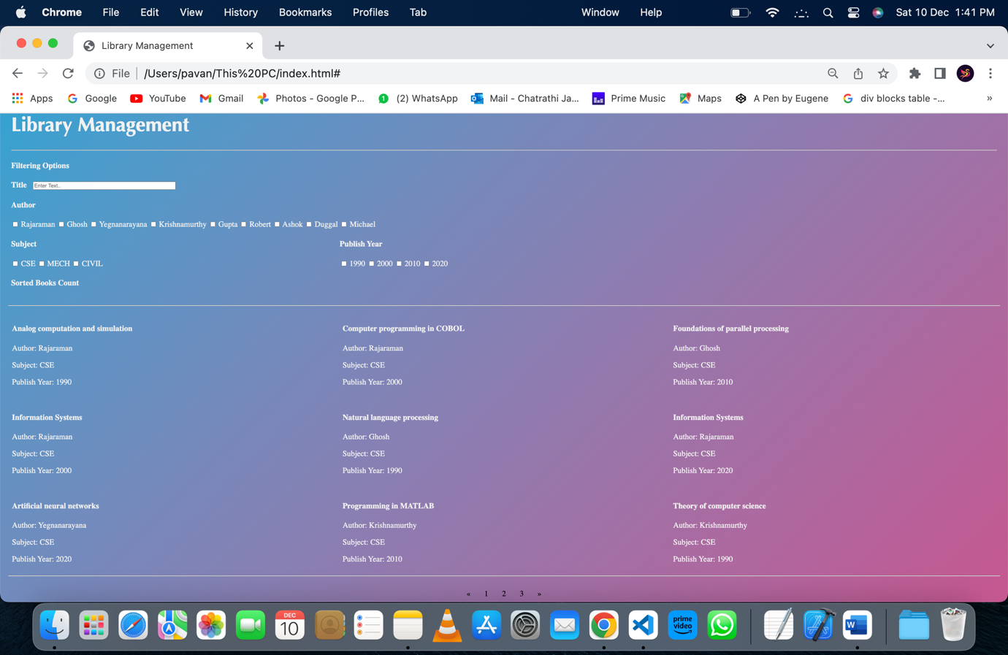

**2. Paging on the list of books:**

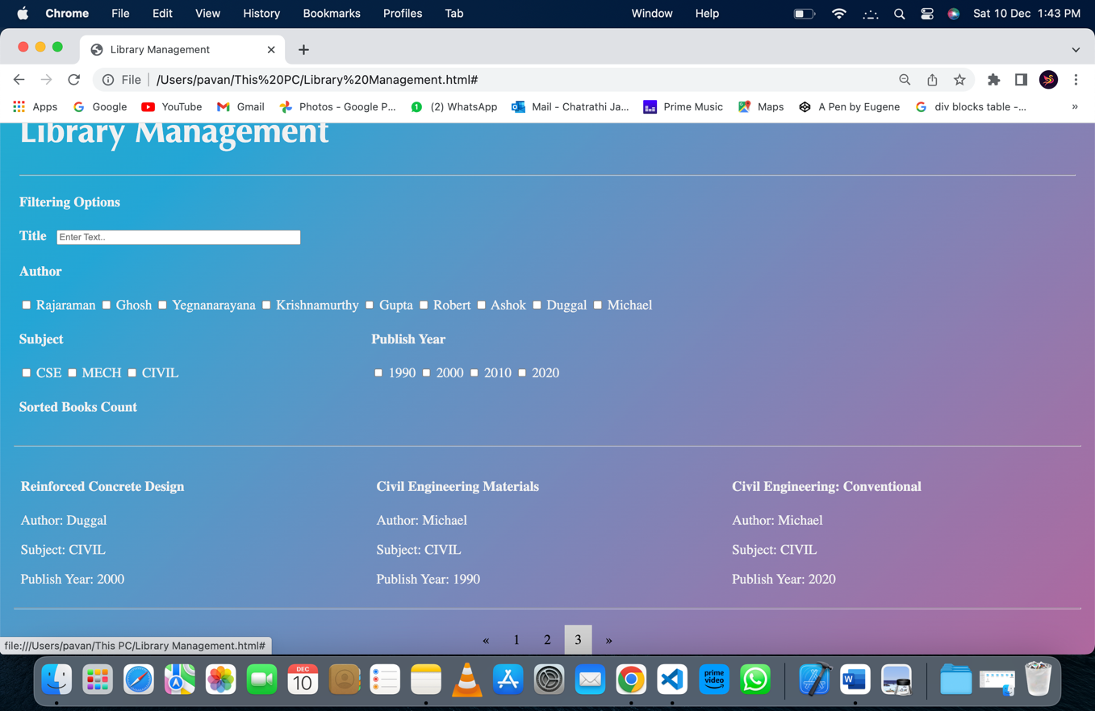

**3.Filtering based on authors names and display count of sorted books:**

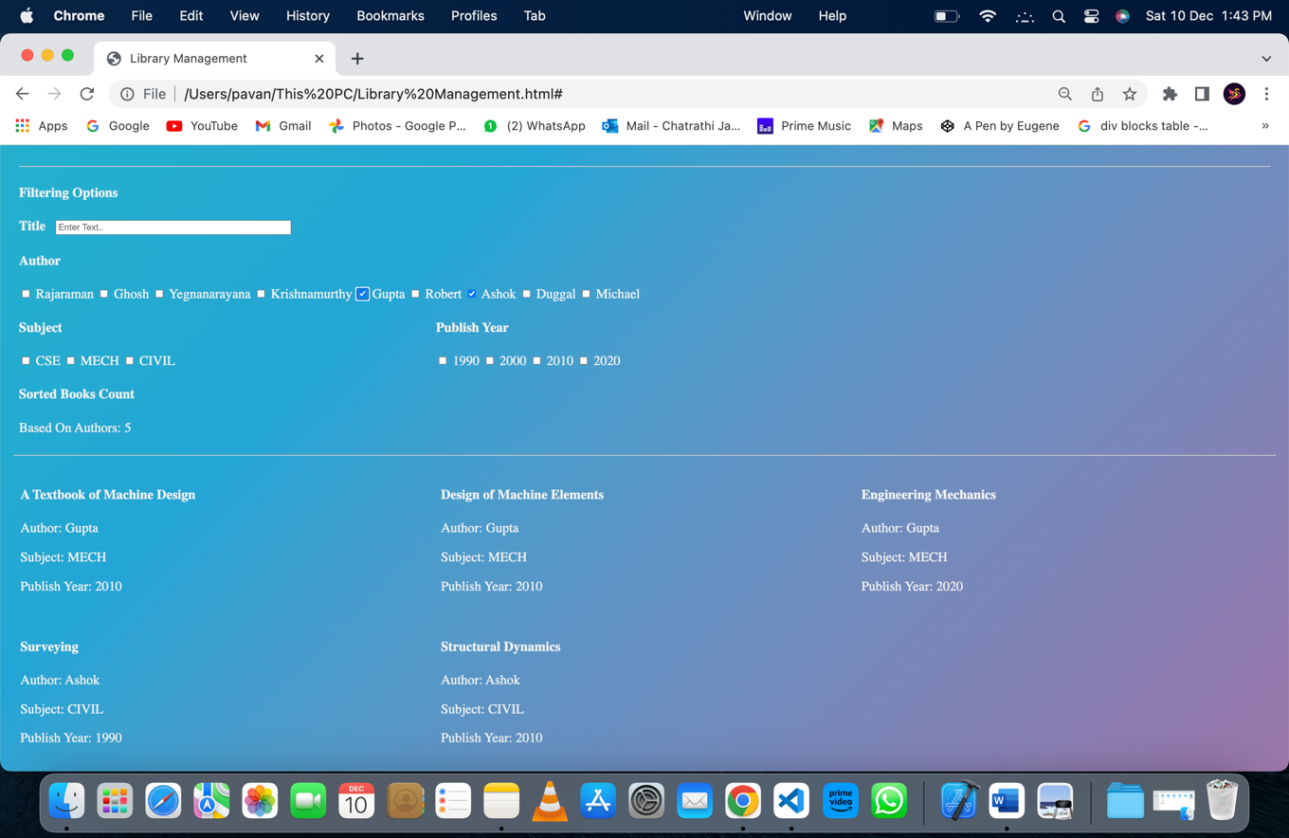

**4.Filtering based on title field:**

**Data Taken:**

Total Number of books: 21

Number of authors: 9

Rajaraman  Ghosh  Yegnanarayana  Krishnamurthy  Gupta  Robert  Ashok

Duggal  Michael

Subjects Count: 3

CSE CIVIL MECH

Publishing Years Count: 4

1990  2000  2010  2020